**Objective**

A supermarket sales store has provided their data based on their sales record and they want to improve customer experience by analyzing sales data as a result to increase their sales revenue. Here we have performed the data cleaning and preprocessing. After understanding our data and data cleaning we have answered the below important questions throughout our analysis.

1) Which age group have the most amount of customers.

2) Which are the top states where most of the orders are coming.

3) Which occupations does the most customers are coming from.

4) Which are the top selling products?

We have also found out important insights which are below:

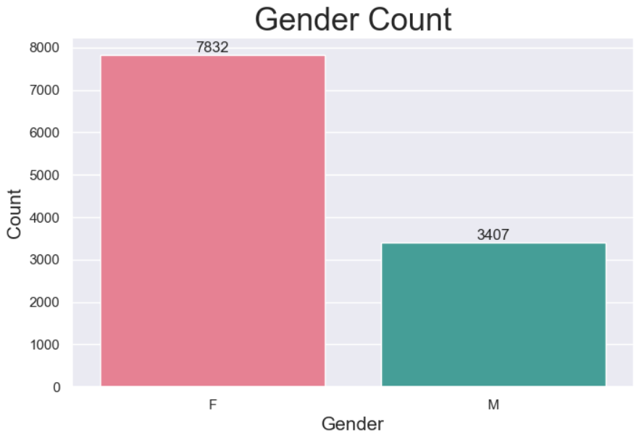

1) The above bar graph shows which gender spends most amount purchasing. So, from this graph we can interpret that the females are spending higher amounts than the male customers.

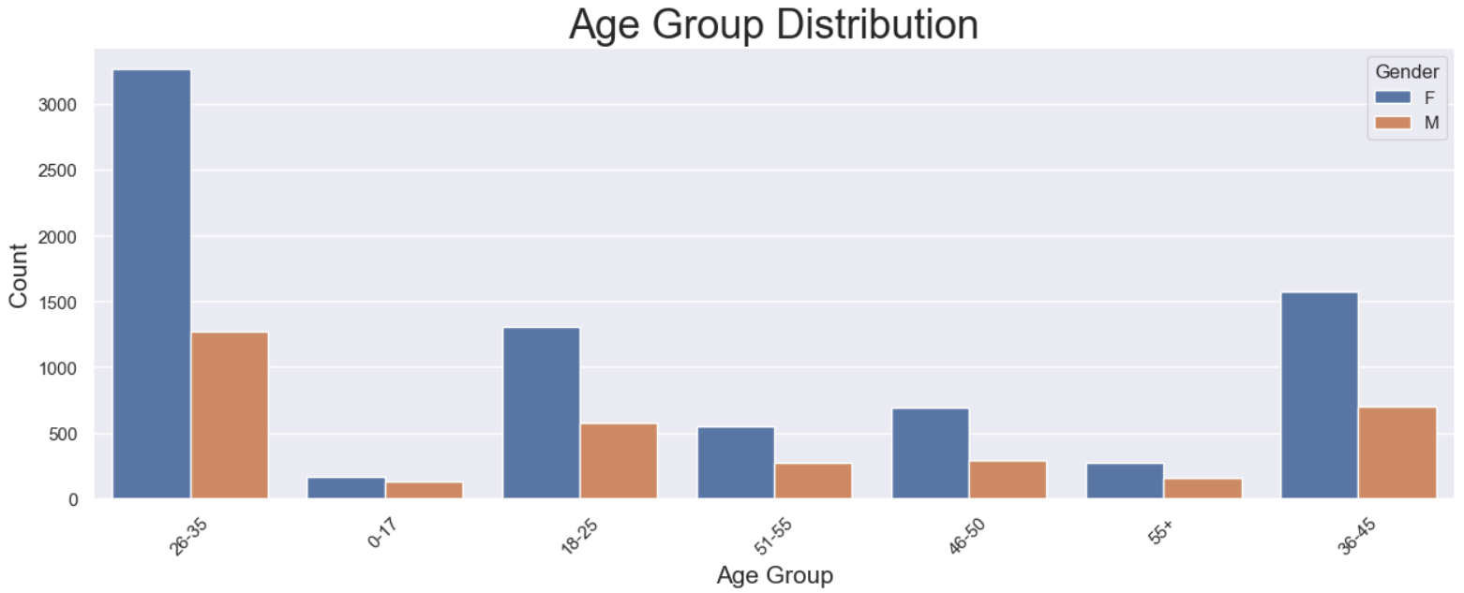

2) The above count plot shows the distribution of age groups. We can interpret that the age group between 26 and 35 are having the highest count among which females outnumber the males in that age group.

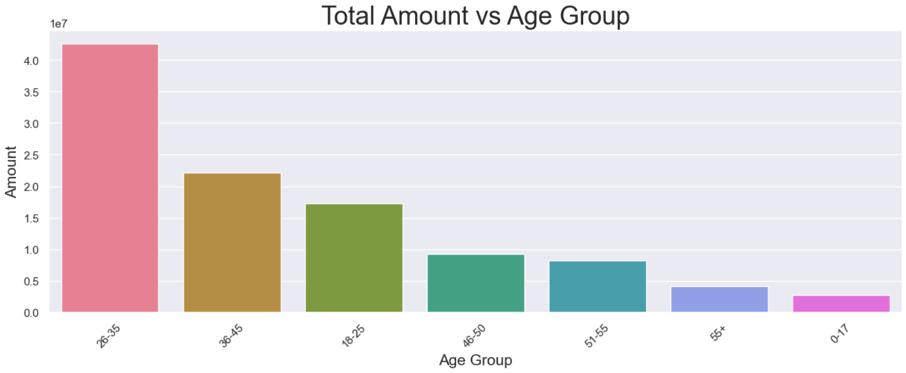

3) The above bar graph shows which age group spends the highest amount. And we can interpret that the age group 26 to 35 spends the highest amount.

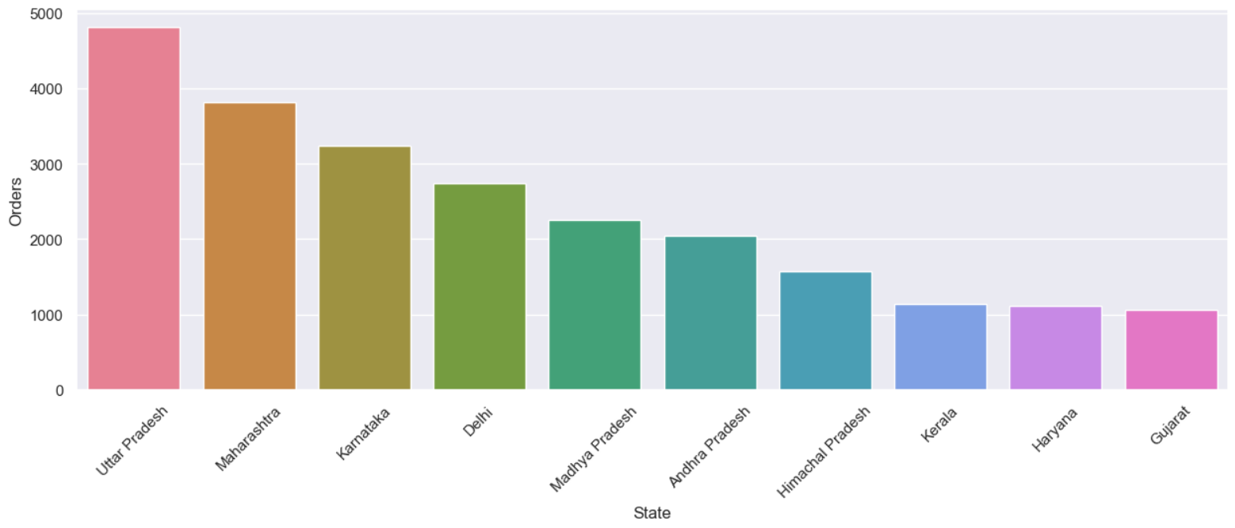

4) The above bar graph shows the top 10 states which captures that highest amount of orders across the country. We can interpret that Uttar Pradesh, Maharashtra and Karnataka are the top 3 states where maximum number of orders are coming.

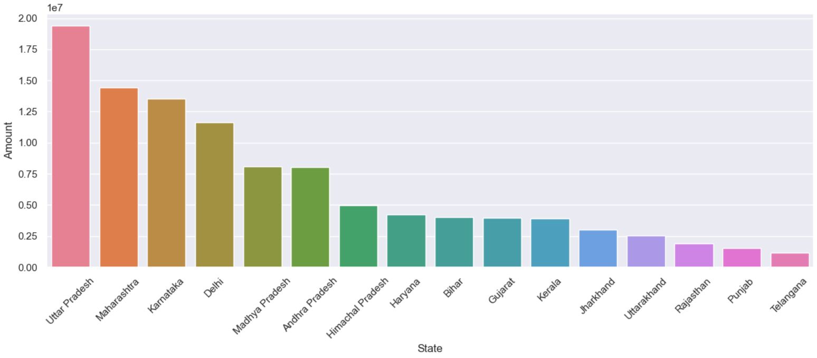

5) The above bar graph shows which state has spend the highest amount of purchase. From the graph, we can interpret that Uttar Pradesh, Maharashtra and Karnataka holds the highest amount of purchase.

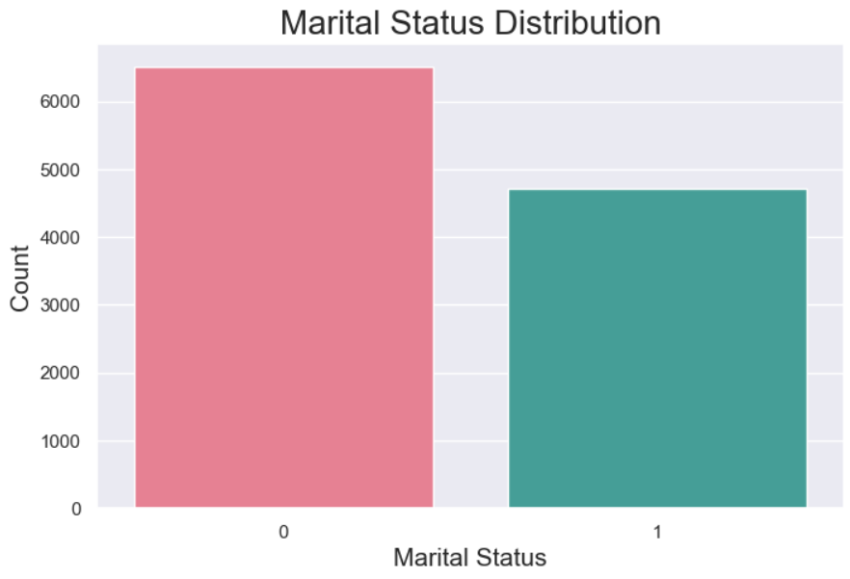

6) The above bar graph shows the Distribution of the Marital Status of the customers. From the graph, we can observe that unmarried customers are higher than the married customers.

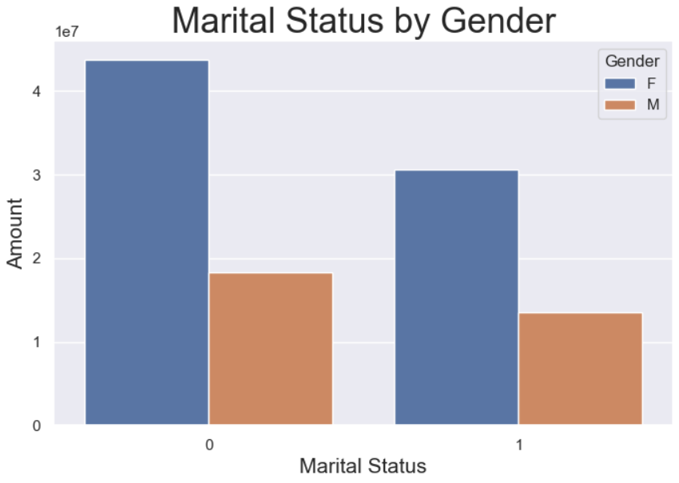

7) The above bar graph shows the marital status by gender. From the graph, we can observe that the married women spends the highest amount compared to married men.

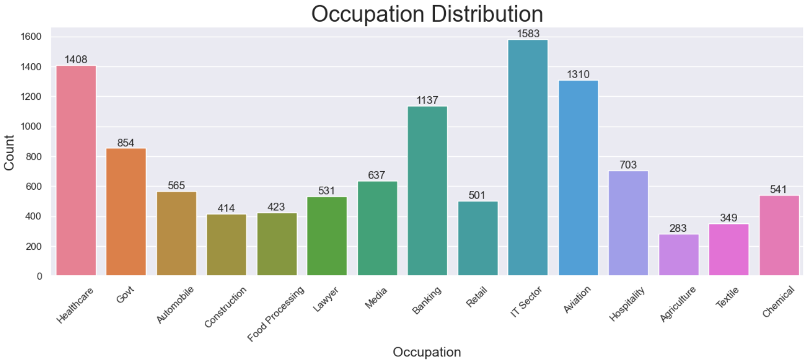

8) The above bar graph showing the highest amount of customer's occupation. From the graph we can interpret that customer's from IT Sector, Healthcare and Aviation have the highest count.

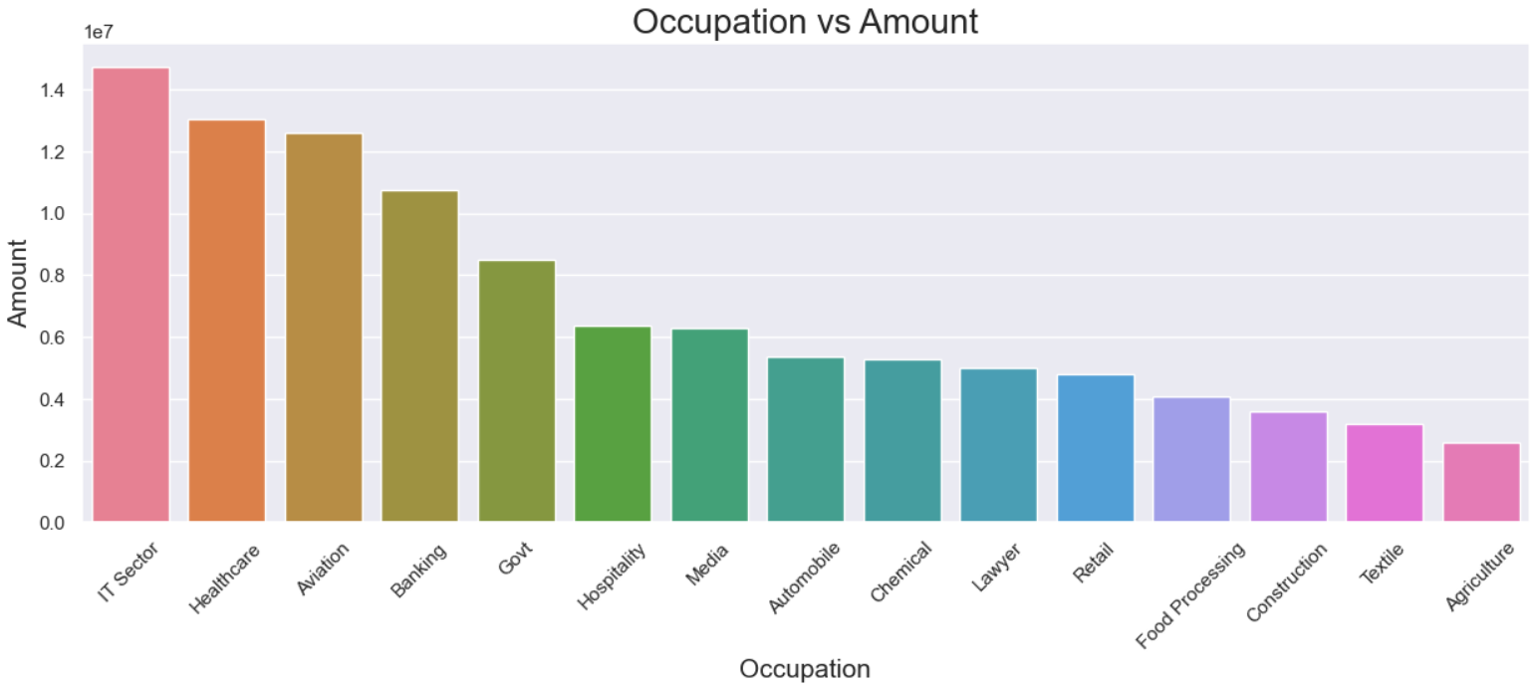

9) The above bar graph showing the highest amount spent by customer's occupations. From the graph we can observe that IT Sector, Healthcare and Aviation spends the highest amount.

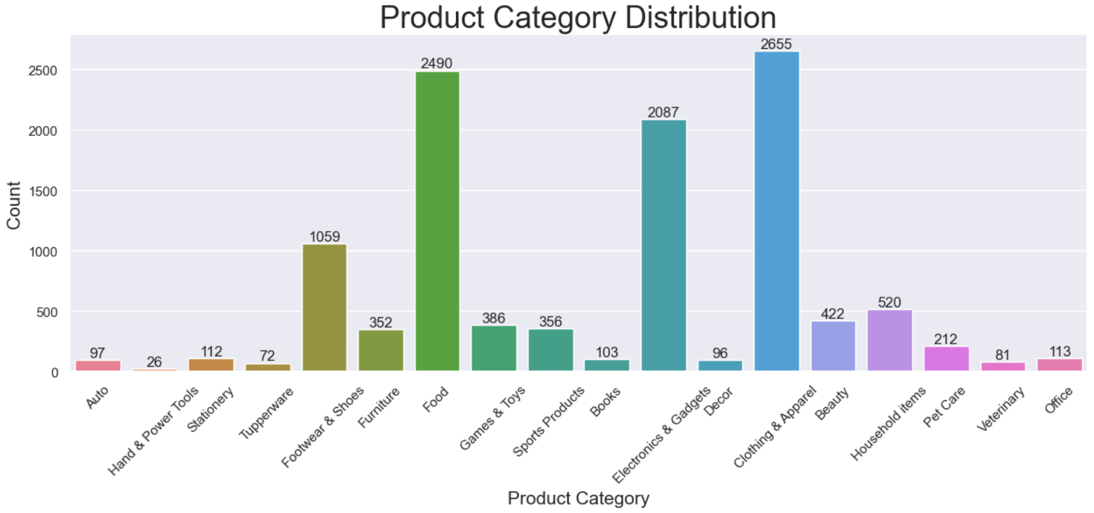

10) The above bar graph showing us the count of product category distribution. From the above graph we can interpret that Clothing & Apparel product, followed by Food and Electronics and Gadgets have the highest count

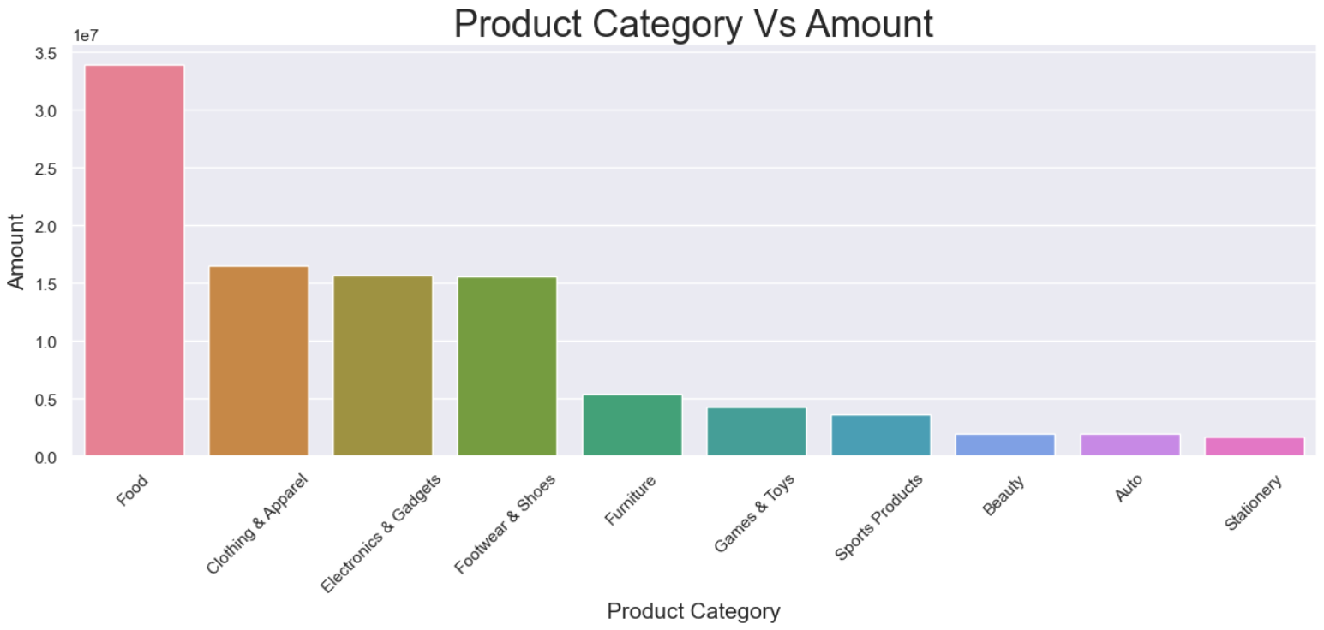

11) A bar graph showing the highest amount of Product spent by customers. From the above graph we can observe that Food, Clothing and Electronics are the most sold items.

**Conclusion:**

1) Married Women age between 26-35 yrs old from Uttar Pradesh, Maharashtra and Karnataka working in IT, healthcare and aviation tends to buy more Food, Clothing and Electronics product items.

2) Food, Clothing & Apparel, Electronics & Gadgets are the most selling items so they should be well stocked so that we don't face any shortage of the products.

3) Special offered can be sent to customers related to IT Sector, Healthcare and Aviation.

4) States like Telangana, Punjab, and Rajasthan are receiving less order so we should target their customers with special offer, coupons or cash back to increase sales.